Name : AL AZHAR RIZQI RIFA’I FIRDAUS
Class : 1I
NIM : 2241720263
Study Program : D-IV Informatics Engineering
Major : Information Technology
Subject : K3
Lecturer : Kadek Suarjana Batubulan, S.Kom, MT

Task 1

- History State Polytechnic of Malang
State of Polytechnic Malang named diploma education program in engineering, Brawijaya University, was opened based on the decree of the director general of higher education, mendikbud No.03/DJ/Kep/1979, established by the government of Indonesia through world bank funds with experts from Swizerland. In 1982, the organizational structure was regulated by presidential decree No. 59 of 1982, named the faculty of non-degree technology, Brawijya Unversity and began accepting students of class I through 4 majors, namely department of electronic engineering, the department of electrical engineering, the department of mechanical engineering , and the department of civil engineering. In 1896, the department of telecommunication engineering, the department of accounting, and the department of commerce administration were opened. The department of accounting and the department of commercial administration receive assistance from the Australian project with Australian experts. Then in 1987 the department of chemical engineering was opened. Furthermore, based on the decree of the minister of national education No./147/O/2004, Brawijaya University Polytechnic has obtained an independent status with the name being the State Polytechnic of Malang. The first director State Polytechnic of Malang is Mr. Umar Nimran. Informatics Engineering was founded in 2010
Photo :
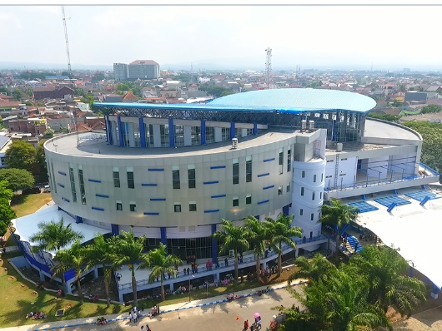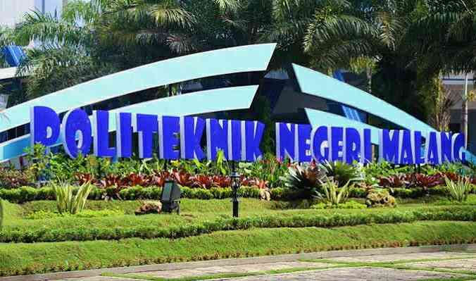

- K3 Devices
- Hydrant
Location information technology department building
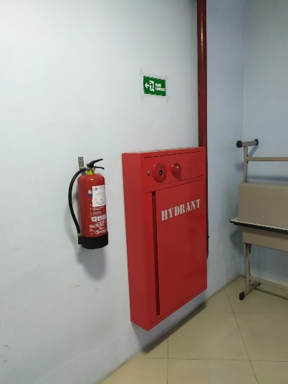

- Evacuation Route
Location information technology department building
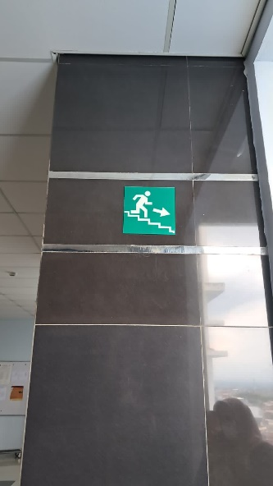

- Elevator Warning
Location information technology department building
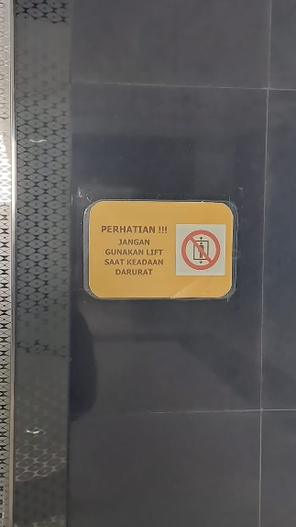

- Ladder
Location information technology department building
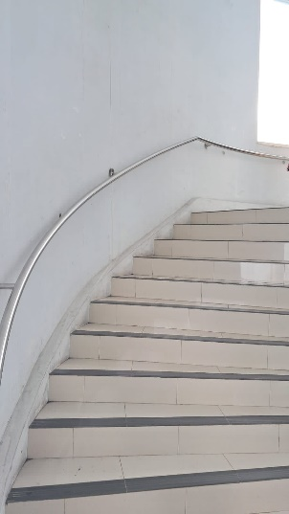

- Fire Sprinkler
Location information technology department building
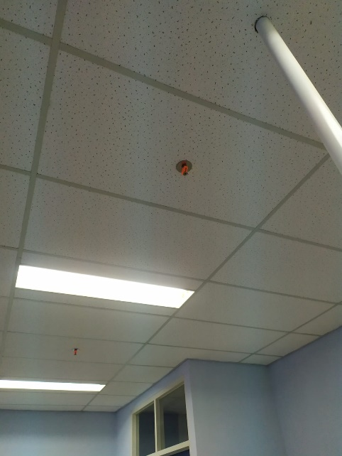

- OSH Symbol

The meaning of the OSH symbol:
- Cross: free from accidents and occupational diseases.
- Gear: work with physical and spiritual health.
- White color: clean and holy.
- Green color: safe, healthy, prosperous.
- Eleven gears: eleven chapters in Law no. 1 of 1970 concerning Work Safety.

